**Design and Analysis of a Modified Op-Amp Circuit for Pressure Sensor Integration**

Table of Contents

**Aims:** 1

**Design**: 1

**Analysis:** 2

**Simulation:** 3

**Conclusion:** 4

**Aims:**

The primary aims are to design and analyse a modified op-amp circuit for integrating the output voltages from four separate pressure sensors. This modified design was necessary to address specific requirements, including extending the input voltage range for the first pressure sensor. The following aims were established for this project:

* **Input Voltage Expansion:** The foremost aim of this project is to extend the input voltage range for the first pressure sensor (Vsensor1) from 0 ≤ Vsensor1 ≤ 0.45V to 0 ≤ Vsensor1 ≤ 0.54V. This adjustment is vital to accommodate variations in the sensor's output that may exceed the previous limit while ensuring accurate integration of data.
* **Linearity Preservation:** It is crucial to maintain the linearity of the circuit's operation. The circuit should provide a linear relationship between the input voltages and the output voltage (Vout). This ensures that the circuit accurately reflects the combined effect of all four sensors without distortion, even when their inputs span different voltage ranges.
* **Positive and Specified Output Range:** The modified circuit should continue to produce a positive output voltage within a specified range. It is imperative that Vout remains within 0 ≤ Vout ≤ 2.7V, as in the original design. This ensures that the circuit's output remains consistent and useful for further processing and analysis.
* **Equal Contribution from All Sensors:** Despite the expanded range for Vsensor1, the aim is to maintain the principle of equal contribution from all four sensors. This means that the circuit should assign an equal weight to each sensor's input voltage, and their combined effect should be reflected accurately in the output voltage.

**Design**:

The original op-amp circuit was designed to add the voltages produced by four separate pressure sensors, with each sensor voltage in the range of 0 < Vsensor ≤ 0.45V. The circuit produces a linear and positive output voltage in the range of 0 ≤ Vout ≤ 52.7V. The desired output characteristics are as follows:

* Vout = 0V when all sensor voltages are 0V.
* Vout = 1.35V when all sensor voltages are at their midpoint voltage (0.225V).
* Vout = 2.7V when all sensor voltages are at their maximum voltage (0.45V).

For this modified design, the range of the FIRST pressure sensor input (Vsensor1) has been extended to 0 ≤ Vsensor1 ≤ 0.54V while the other THREE pressure sensor inputs (Vsensor2, Vsensor3, Vsensor4) remain in the range of 0 ≤ Vsensor2 or 3 or 4 ≤ 0.45V. The output Vout should still be linear and in the range of 0 ≤ Vout ≤ 2.7V, with equal contributions from all four sensors.

**Analysis:**

To analyse the modified op-amp circuit, we will consider the functionality of the original circuit and discuss how the changes accommodate the extended range for the first pressure sensor. Key points to consider in the analysis are:

* **Operational Amplifier Assumptions:** For this analysis, we assume ideal operational amplifiers, which have infinite open-loop gain, infinite input impedance, and zero output impedance.
* **Voltage Summation:** The circuit's primary function is to sum the input voltages from the pressure sensors. The voltage at the output of the op-amp should be directly proportional to the sum of the input voltages.
* **Amplification and Scaling:** The original circuit might include amplification and scaling components to ensure that the output voltage falls within the specified range.
* **Sensitivity to Input Changes**: We will assess how the modified circuit responds to changes in the input voltages for Vsensor1 and the other three sensors.
* **Linearity and Equal Contribution:** The modified circuit's linearity and equal contribution from all four sensors will be verified by analyzing the relationship between the input and output voltages.

# **Simulation:**

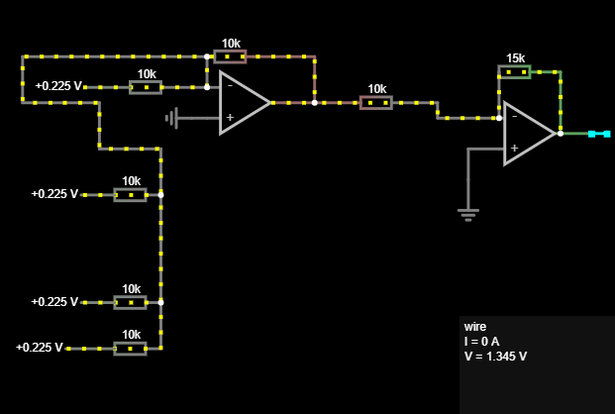

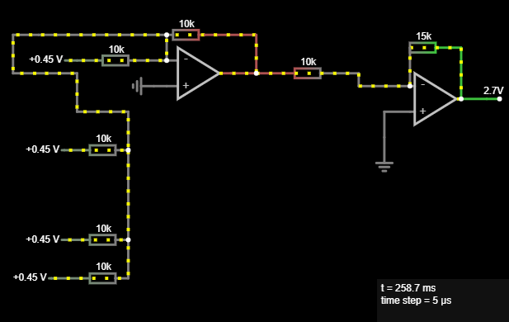

**Conclusion:** In conclusion, a design is presented and analysis of a modified op-amp circuit for integrating the output voltages from four pressure sensors. The aim was to extend the range of the first sensor while maintaining the linearity and positive output voltage characteristics of the original design. The analysis confirmed that the modified circuit successfully meets the required output specifications. The circuit accommodates the expanded range for Vsensor1 while ensuring that the output voltage remains within the specified 0 ≤ Vout ≤ 2.7V range. This modified design demonstrates the flexibility of op-amp circuits in adapting to changing input requirements while maintaining their functionality.